**CLONE REPO FROM GIT**

**URL** : <https://github.com/mpyogaesh/Contacts.git>

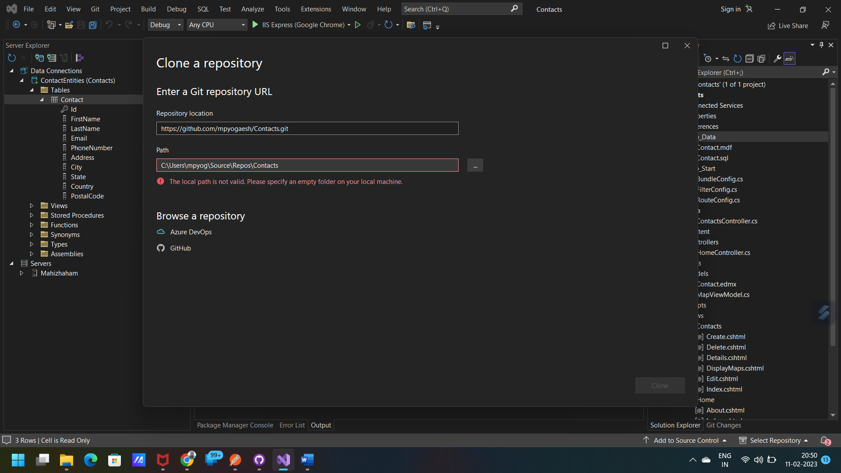

**DATABASE**

Name: Contacts.mdf

Table Name : Contacts

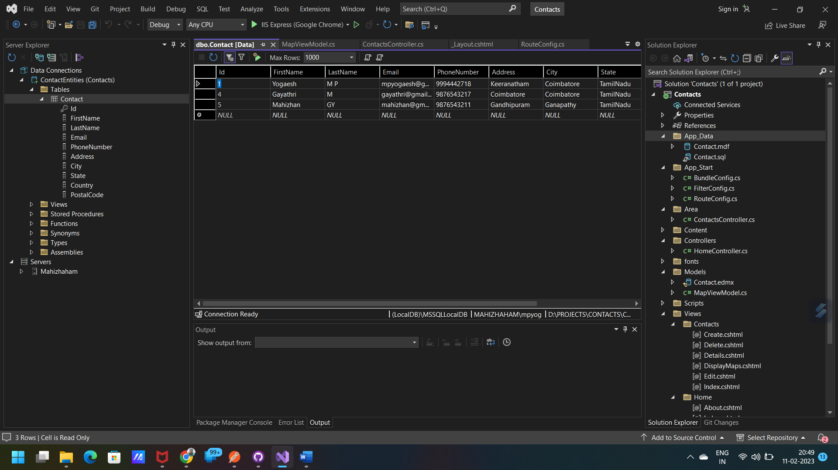

**PACKAGES**

**Sorting**

* bootstrap-sortable
* Moment.js

**CDN**

**Maps**

* Openstreetmap

**Note**

Google Maps requires API Key for Implementation so I have usedOpenstreetmap

**Additional Implementation**

Displayed maps in Contacts Details Page

**NAVIGATION**

Home

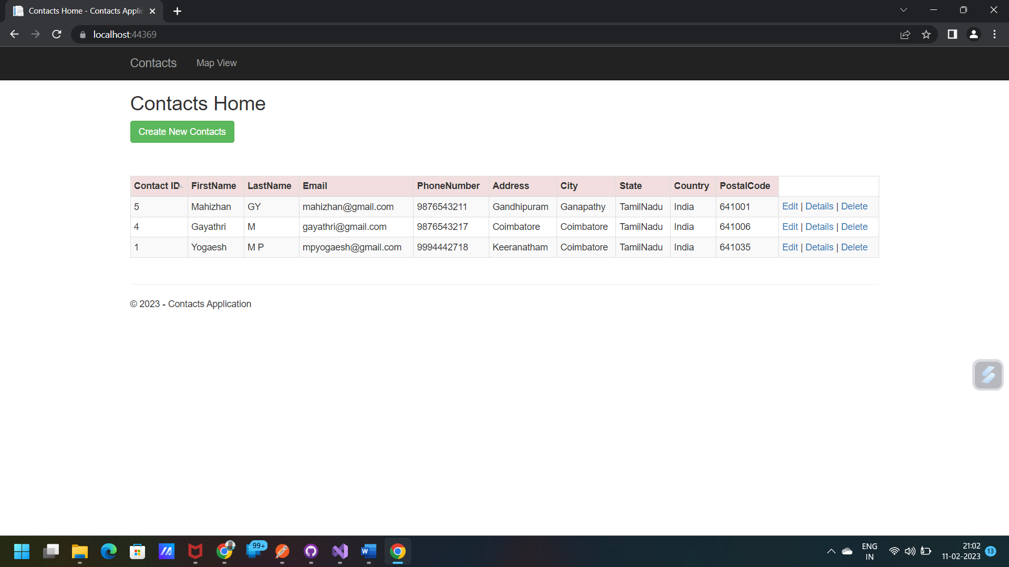

Create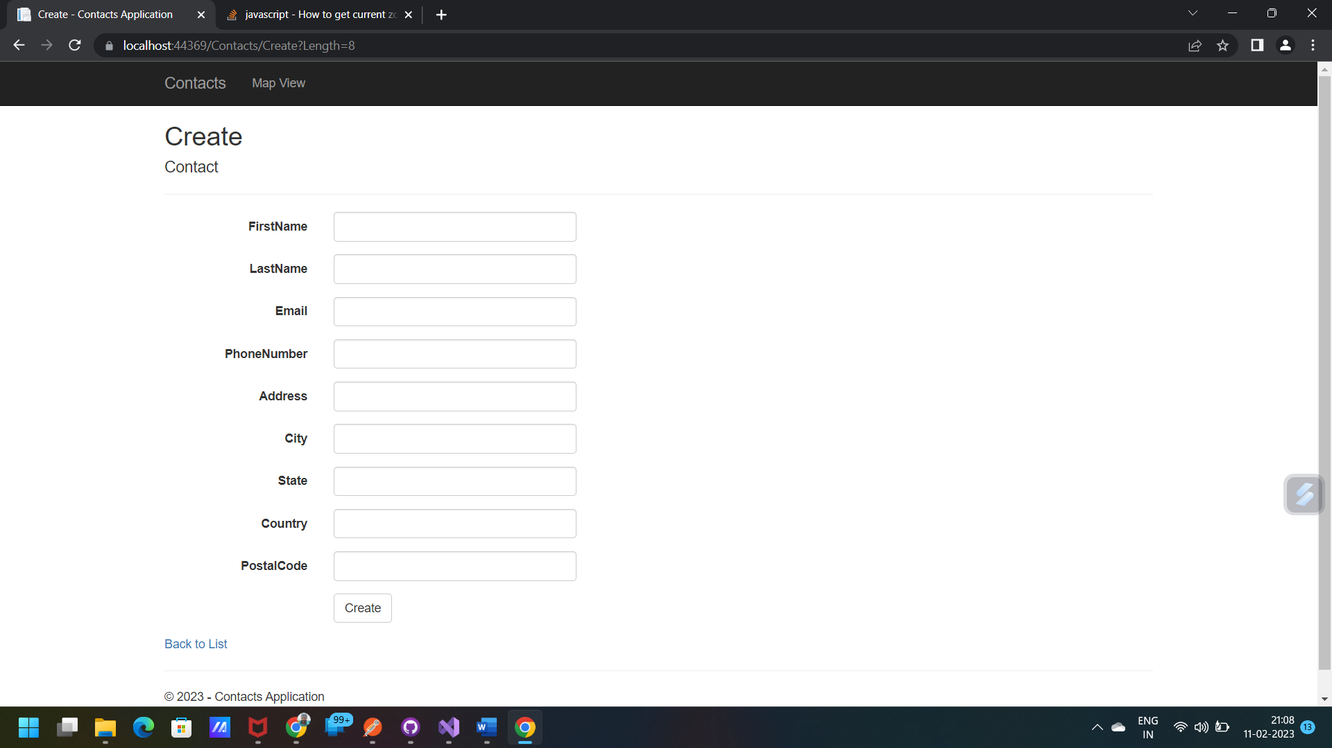

Details

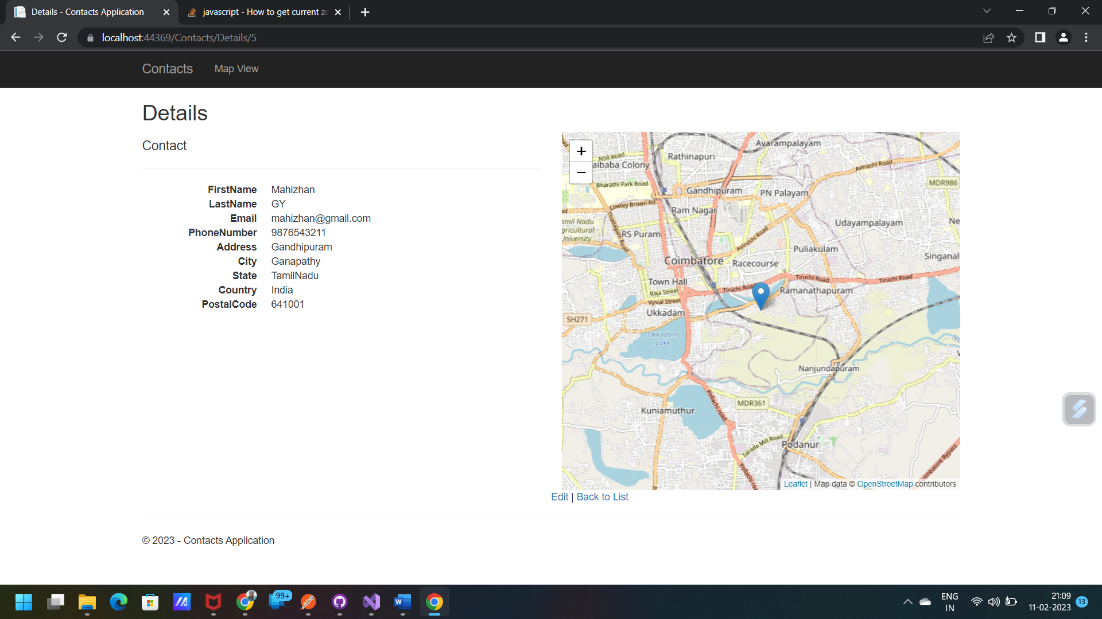

Edit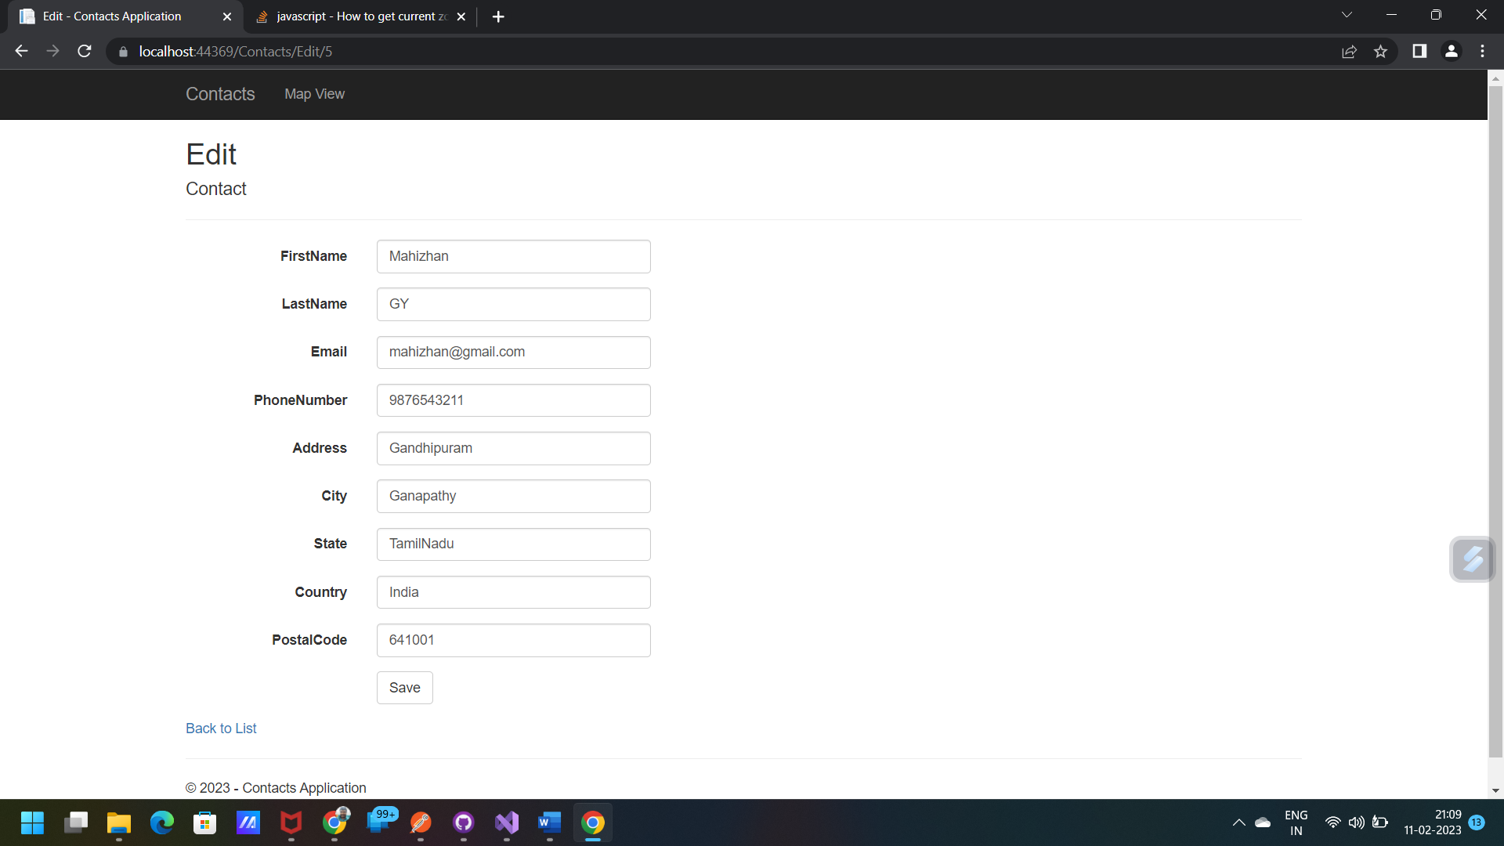

Delete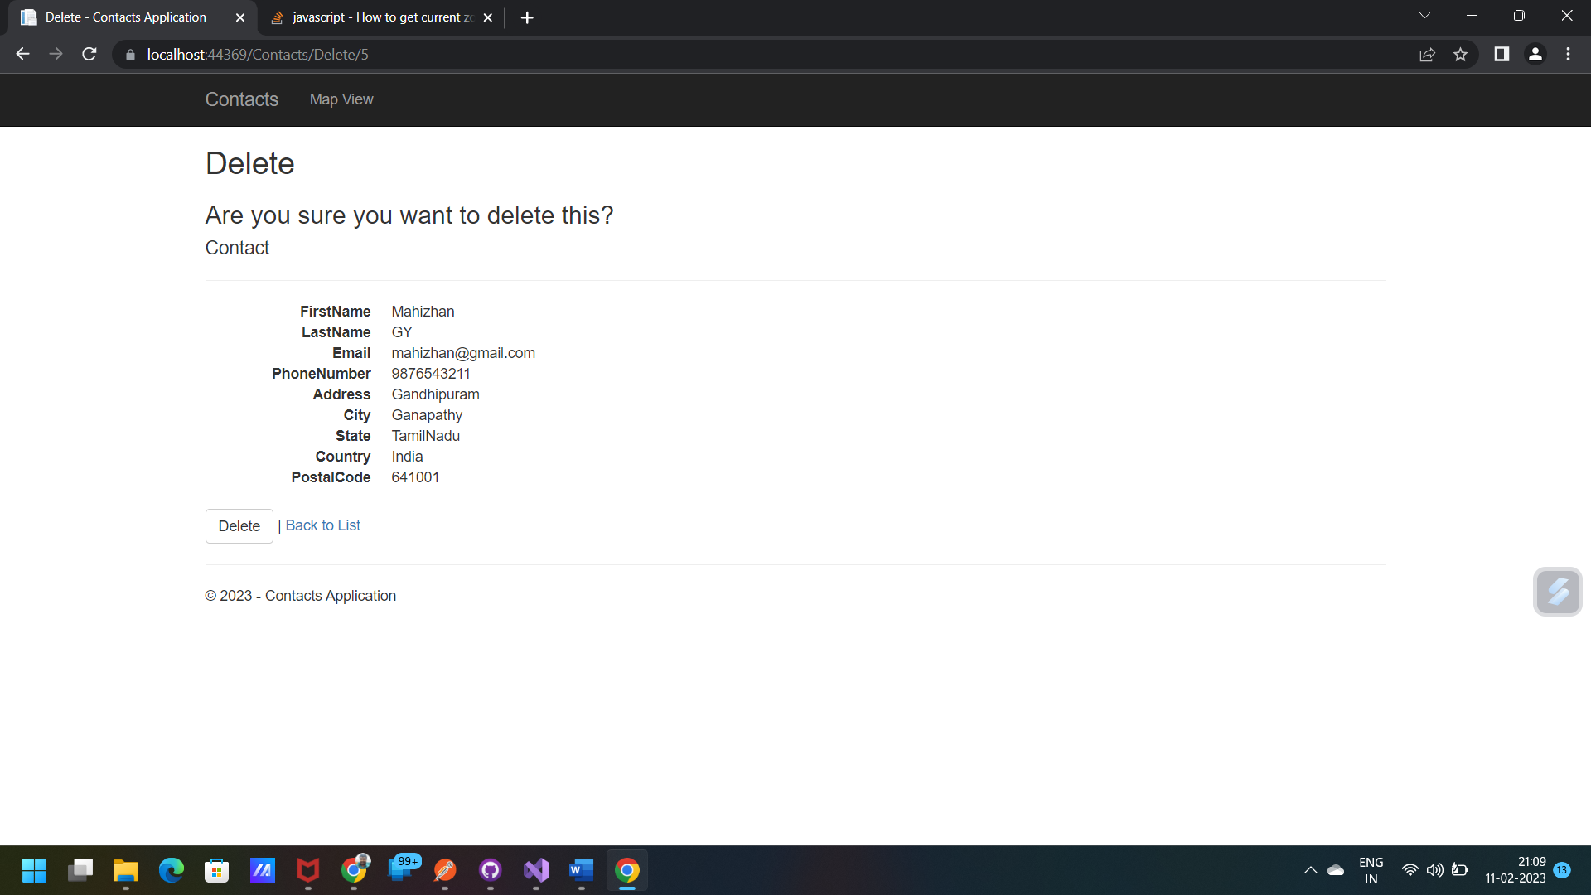

Navigation

